Chapter 8, Problem 2.

Using Fig. 8.63, design a problem to help other students better understand finding initial and final values.
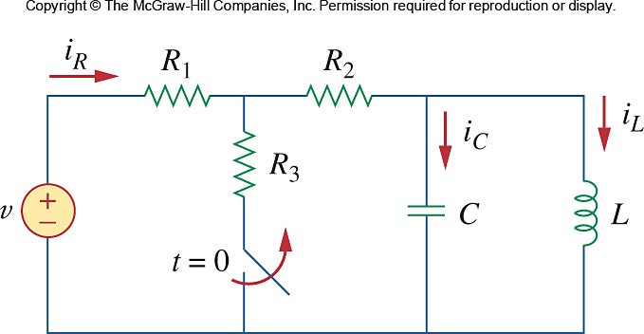

Figure 8.63
For Prob. 8.2.

